PRESS RELEASE

Kverneland presents new range of Mechanical Weeding

Rotary Hoe Helios

Efficient weed control for healthy plant growth

August, 2023: Arcy-sur-Cure, France

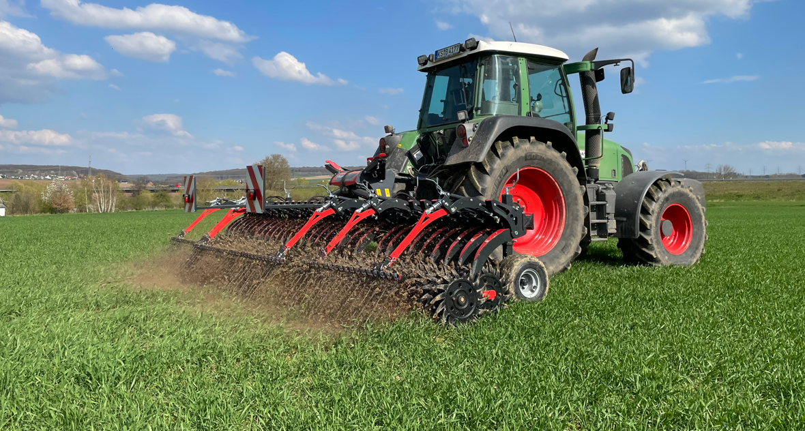

*Kverneland Helios 2060 F*

Efficient weed control is needed for healthy plant growth as the basis for yield and profit, as well as for a safe food production. At the same time, the protection of the environment has become a key topic in today’s agriculture. With the Farm to Fork Strategy, recent European regulations and policies have defined new standards and reduced the kinds of components allowed.

With the new rotary hoe, Helios, Kverneland offer solutions, which perfectly fit for the future of sustainable farming and enable the customers to achieve efficient, accurate and consistent cultivation and weed control. The Kverneland Helios will be offered in working width from 3m rigid to 6.4m folding models.

“Mechanical weeding with the rotary hoe, Helios, in row crops and on cereals is an efficient tool for weed control and it also works in case of resistance as there are Sulfonyloureas and Pinoxaden for example. It also extends the option to react when conditions limit the application of chemical crop care,” Maxime Georges, Junior Product Manager explains. “In addition, by cracking the upper topsoil, breaking the surface capping on certain soils after rain, the rotary hoe, Helios, promotes the seed emergence and restores the water and air flow, stimulating physico-chemical reactions and soil life. It will increase mineralization and biomass by promoting the absorption of nitrogen.”

**Strong in weed control, gentle to the crops**

The Helios is fitted with cast-iron, ground-driven star wheels. These excel by the special back-of-spoon design which allow a good performance even with low working speeds in difficult conditions without any blockages. Curved upwards, they work without digging by gravity. Weeds are lifted with no splashes or projections thus reducing the impact on the crop.

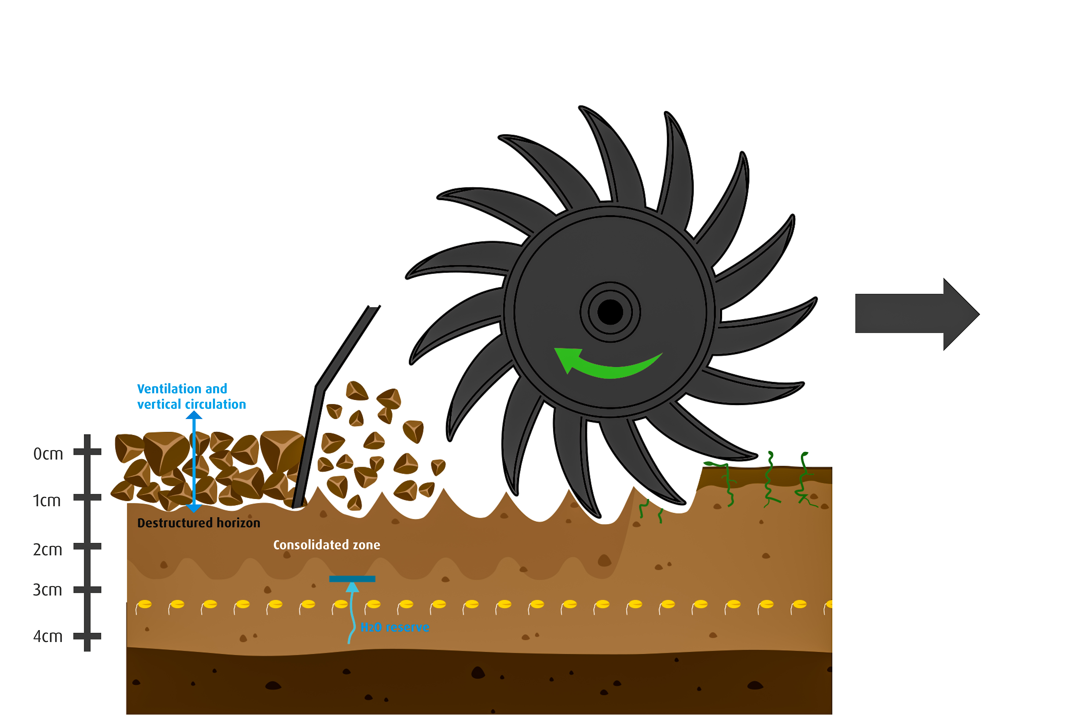

*The Helios concept with the rotary driven star-wheel design*

Various actions are carried out all in one pass:

* Destroying or pulling up the weed
* Breaking up the capped soil surface
* Destructuring and aerating the top horizon
* Consolidating the subsoil while maintaining the water supply of the seedbed

**Perfect performance and customer focus – precise and easy adjustment**

Selective mechanical weeding asks for precision in adjustment to the soil conditions, the weed pressure and the machinery of the farm. With the Helios, all these adjustments can be easily and quickly done without the need for tools. Equipped either with spring or hydraulic “soft control” pressure overload protection, the Helios ensures a constant working depth over the entire working width, independent of the surface. Adjusted to the height of crop emergence and sowing depth, the negative impact on the crops is reduced. A precise speed management can be set up to work as aggressively as necessary, maximising performance and output.

**A perfect finish - levelling and soil flow regulation**

In order to ensure perfect levelling and to create an even weatherproof surface, Kverneland offers an one row following finger harrow in the final working zone. The rear-harrow operates over the entire working width of the Helios. The following harrow finishes the job and

preserves the seedbed. It restores the fluids, water, air and stimulates physico-chemical reactions and soil life.

The following harrow supports the weed control as it uncovers and pulls the uprooted weeds out of the soil, leaving them on the surface to dry out in the sun. Regrowth is practically impossible which is particularly important with rhizome and other weeds that could start growing again.

First implements have been in field all over Europe this season.   
The Helios will be fully available from 1st September.

Number of characters including spaces: *3791*

\*\*\*

**Kverneland is a brand of Kverneland Group**

Kverneland Group is a leading international company developing, producing and distributing agricultural implements, electronic solutions and digital services. Productivity, efficiency, and sustainability are three important principles in today's agriculture, driving us every day to continuously develop our Agricultural Implement Technology. Kverneland Group offers an innovative range of soil and seeding equipment, forage and bale equipment, spreading, spraying, electronic solutions and digital farm services for agricultural tractors and implements. For more information on Kverneland Group, visit [www.kvernelandgroup.com](http://www.kvernelandgroup.com)

- - END - -

[Kverneland Helios\_youtube](https://youtu.be/6rWWTdYIe0E)

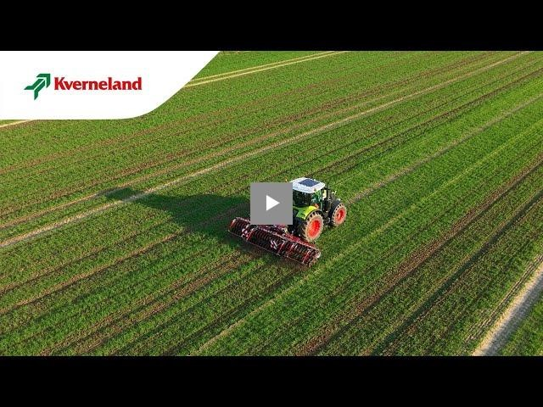

Download high resolution images

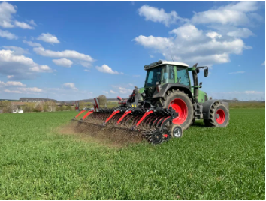  
[*Kverneland-Helios 2060F field work (image 1)*](https://download.kvernelandgroup.com/Media/Images/kverneland-helios-2060f-field-work.jpg)

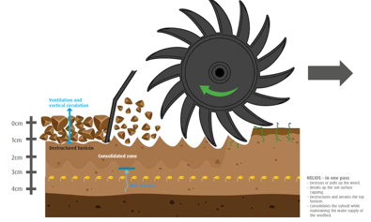  
[*The Helios concept with rotary driven star-wheel design* (image 2)](https://download.kvernelandgroup.com/Media/Images/kverneland-helios-princple-en.jpg)

**For Details, Contact:**

Carl Thestrup  
011-8000 809 / 070-812 21 37  
carl.thestrup@kvernelandgroup.com

|  |  |  |  |  |  |  |  |
| --- | --- | --- | --- | --- | --- | --- | --- |
|  | | | | | |  | |
|  |  |  |  |  |  |  |  |

|  |  |  |  |  |  |  |  |  |  |  |
| --- | --- | --- | --- | --- | --- | --- | --- | --- | --- | --- |
| **Kverneland on Social Media** | | | | | | | |  | | |
| 2020-07-30_SocialMediaIcons_RGB_Facebook | | [Kverneland](http://www.facebook.com/KvernelandGroup) | 2020-07-30_SocialMediaIcons_RGB_Twitter | [@KvernelandGroup](http://twitter.com/kvernelandgroup) | 2020-07-30_SocialMediaIcons_RGB_YouTube | [kvernelandgrp](http://www.youtube.com/kvernelandgrp) | 2020-07-30_SocialMediaIcons_RGB_Instagram | [Kverneland](https://www.instagram.com/kverneland_ien/) | | 2020-07-30_SocialMediaIcons_RGB_LinkedIn | [Kverneland Group](https://www.linkedin.com/company/kverneland-group/) | |