PRESS RELEASE

Kverneland presents new range of Mechanical Weeding

Inter-row cultivator Kverneland Onyx with guidance interface Lynx

Efficient and sustainable weeding will safeguard yields and respect the environment

August, 2023: Arcy-sur-Cure, France

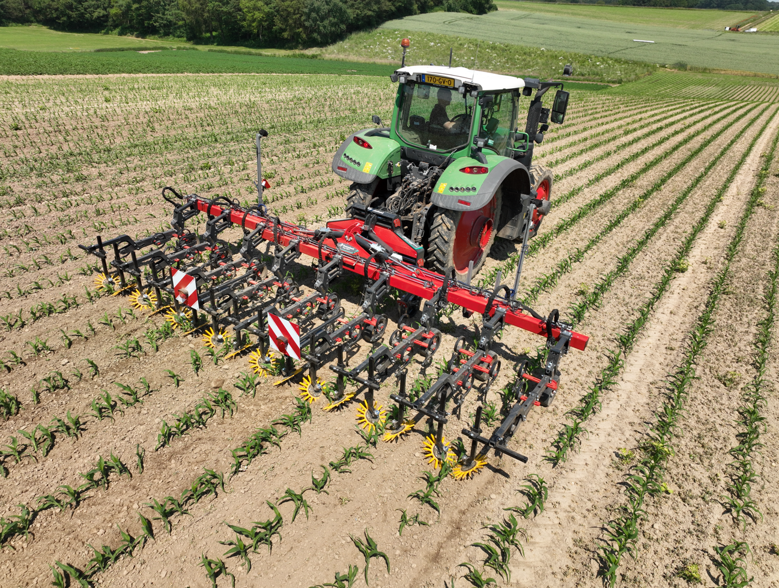

*Kverneland inter-row-cultivator Onyx with guidance interface Lynx*

**Efficient and sustainable farming**

One of the major challenges of todays’ agriculture is the reconciliation of efficient weed control, agronomic challenges and the protection of the environment. A strong plant development will safeguard yields and farmers’ income. With new standards defined in the Farm to Fork policy limiting the quantity and choice of active chemicals allowed, as well as the resistance of several weeds against herbicide, there is the need for alternatives in effective weed control in row crops as well as on cereals.

“The inter-row cultivator Kverneland Onyx works in case of resistance and can be used in row crops and cereals,” Maxime Georges, Junior Product Manager explains. “It will get as close to the plants as possible without damaging the crops by ensuring the straight line within the row. For different crops and row widths, a quick adaptation is possible thanks to a strong modular concept on this machine.”

**Best results in row crops and cereals**

The inter-row cultivator Onyx is ready for large performance with high accuracy. Fitted with the double H-shaped frame, the Kverneland Onyx excels by maximum rigidity and adaptability even down to 12.5cm row width. A constant depth control over the entire working width ensures best results in row crops and cereals.

A wide range of shares in Hardox and Tungsten Carbide quality as well as a full range of accessories such as ridger discs, side deflectors and finger weeders are available to meet all sorts of requirements and conditions. Due to the largest diameter of gauge wheel is in the market, any bulldozing effect is avoided.

Each element is working independently. If fitted with Section Control, up to 13 sections are automatically lifted by ISOBUS.

**Stimulating physico-chemical reactions and soil life**

The shallow tillage at 2cm by the Kverneland Onyx improves aeration of the soil as a prerequisite to physicochemical reactions (humification, mineralisation of organic nitrogen). The crops will benefit from the plus of nutrients available with positive impact on the yield.

**Protecting soil moisture**

By the flat-bed weeding, the Kverneland Onyx creates an isolating layer to stop the capillary rising of water to the surface protecting the soil moisture within the seed layer.

“One pass of weeding is like two times watering,” says a proverb. With view to the climate change, this is of major importance in dry areas and a general benefit for the crop’s start and growth.

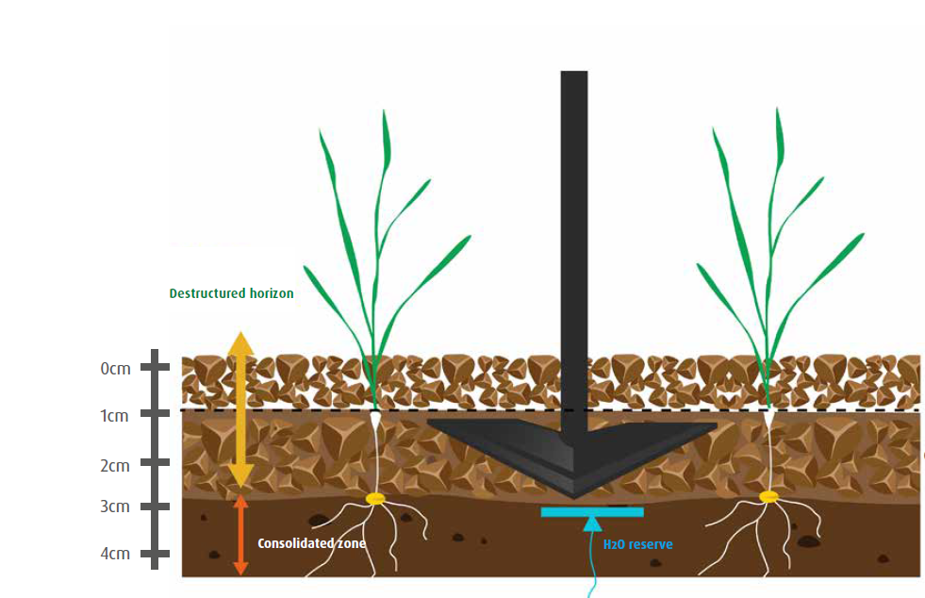

*Kverneland ONYX combines effective weeding, breaking capped surface, protecting soil moisture*

**High accuracy and extra flexibility – guidance interface Lynx**

For utmost accuracy also with wider implements and when working in challenging geography on slopes, the inter-row cultivator Onyx can be combined with the Guidance Interface Lynx. Due to the lateral movement of up to 25cm either side, precise weeding is ensured.

LYNX is equipped with an HR, colorimetric analysis camera, Tillett & Hague technology, an optional 2nd camera can be added to protect the plants by keeping the machine on track, even in hilly conditions or on odd-shaped headlands. There is an optional crop feeler for working in developed crops. LED lights allow good working results also in the dark.

Quickly adapting the track width to different crops, working width and performance, the guidance interface, LYNX is adding extra flexibility to the inter-row cultivator to suit various farm sizes.

First implements have been in field all over Europe this season.

The Onyx and Lynx will be fully available from 1st September 2023.

**Extended application by combined systems**

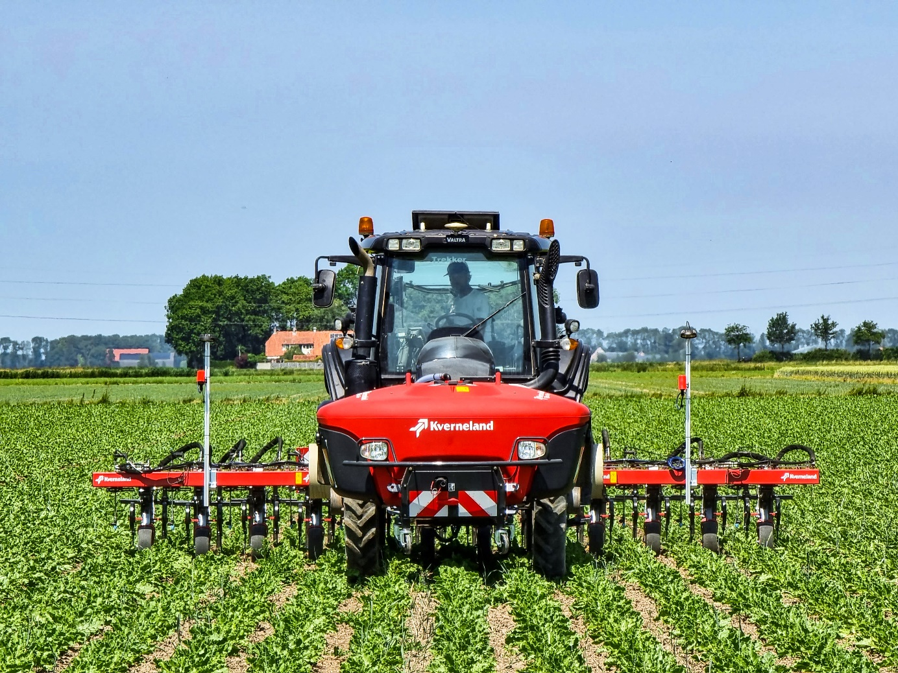

*Combined systems in development: here Kverneland Onyx with iXtra LiFe*

In order to extend application possibilities, Kverneland will offer combined systems of mechanical weeding with chemical crop care and fertiliser application:

* The Kverneland Onyx can be combined with the Kverneland iXtra LiFe for band spraying or the application of liquid fertiliser.
* In combination with Kverneland a-drill and f-drill, the simultaneous application of solid fertiliser or companion crop in one pass with the mechanical weeding process is possible.

These developments are in process and will be available as O-series from 2024.

Number of characters including spaces: *4512*

\*\*\*

**Kverneland is a brand of Kverneland Group**

Kverneland Group is a leading international company developing, producing and distributing agricultural implements, electronic solutions and digital services. Productivity, efficiency, and sustainability are three important principles in today's agriculture, driving us every day to continuously develop our Agricultural Implement Technology. Kverneland Group offers an innovative range of soil and seeding equipment, forage and bale equipment, spreading, spraying, electronic solutions and digital farm services for agricultural tractors and implements. For more information on Kverneland Group, visit [www.kvernelandgroup.com](http://www.kvernelandgroup.com)

- - END - -

Product videos on youtube

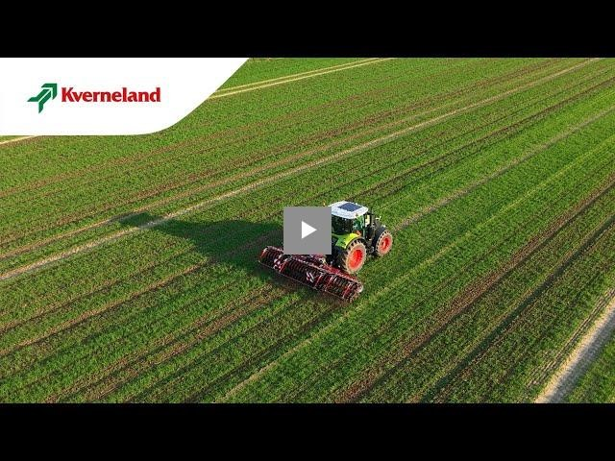

[*Kverneland Onyx Inter-row Cultivator in Cereals\_youtube*](https://youtu.be/_3wwczenTqE)

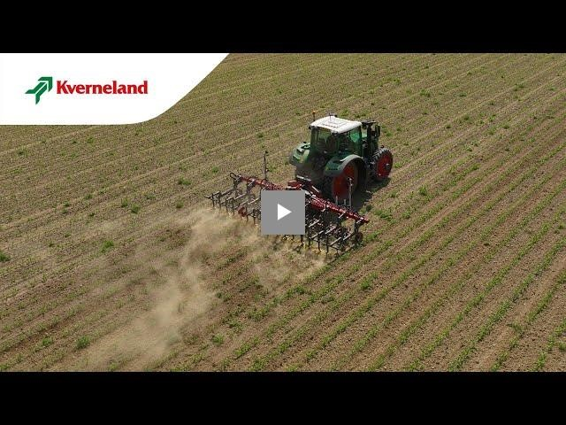

[*Kverneland Onyx Inter-row Cultivator in row crops\_youtube*](https://youtu.be/9ti7YFo1dSM)

Download high resolution images

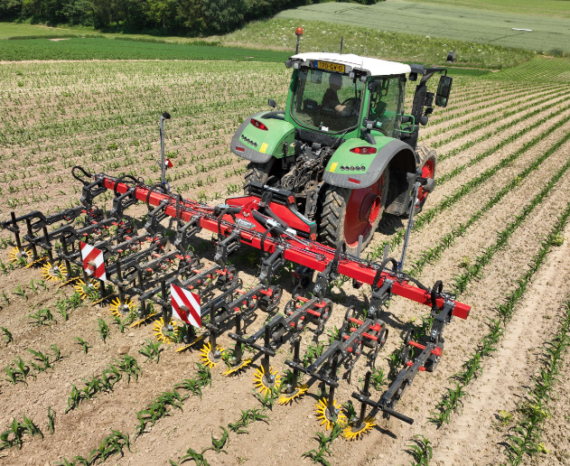  
[*Kverneland-inter-row cultivator Onyx with Lynx guiding interface in maize field* (image 1)](https://download.kvernelandgroup.com/Media/Images/kverneland-onyx-lynx-in-maize.jpg)

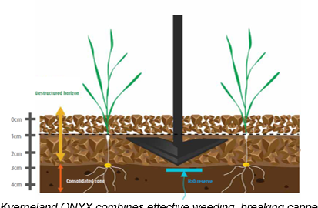

[*Kverneland ONYX combines effective weeding, breaking capped surface, protecting soil moisture (image 2)*](https://download.kvernelandgroup.com/Media/Images/kverneland-onyx-drawing-en.jpg)

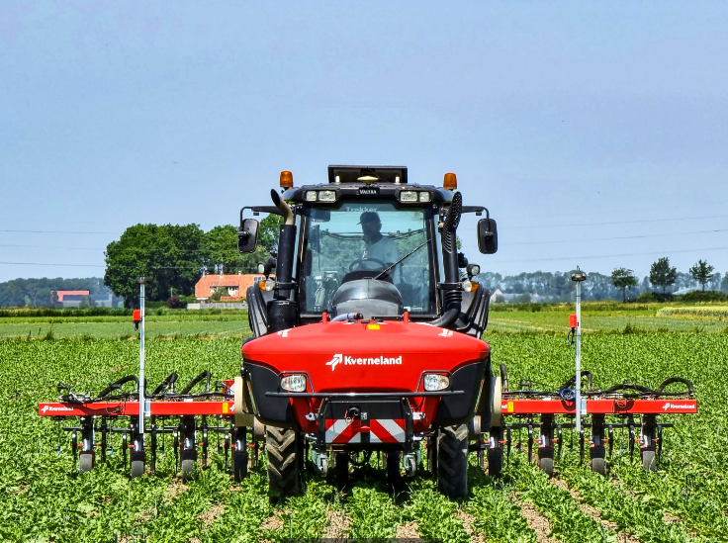)  
[*Kverneland-Onyx inter-row cultivator in combination with iXtra LiFe for band spraying in combined operation* (image 3)](https://download.kvernelandgroup.com/Media/Images/kverneland-onyx-ixtra-life-field-01.jpg)

**For Details, Contact:**

Carl Thestrup

011-8000 809 / 070-812 21 37

carl.thestrup@kvernelandgroup.com

|  |  |  |  |  |  |  |
| --- | --- | --- | --- | --- | --- | --- |
|  |  |  |  |  |  |  |

|  |  |  |  |  |  |  |  |  |  |  |
| --- | --- | --- | --- | --- | --- | --- | --- | --- | --- | --- |
| **Kverneland on Social Media** | | | | | | | |  | | |
| 2020-07-30_SocialMediaIcons_RGB_Facebook | | [Kverneland](http://www.facebook.com/KvernelandGroup) | 2020-07-30_SocialMediaIcons_RGB_Twitter | [@KvernelandGroup](http://twitter.com/kvernelandgroup) | 2020-07-30_SocialMediaIcons_RGB_YouTube | [kvernelandgrp](http://www.youtube.com/kvernelandgrp) | 2020-07-30_SocialMediaIcons_RGB_Instagram | [Kverneland](https://www.instagram.com/kverneland_ien/) | | 2020-07-30_SocialMediaIcons_RGB_LinkedIn | [Kverneland Group](https://www.linkedin.com/company/kverneland-group/) | |