PRESS RELEASE

PUDAMA with Precision Drill Kverneland Optima F

Range of Precision Drill Models with Spot Fertiliser Application Enlarged:
PUDAMA now also incorporated on Folding Frame Optima F

August 2023 Soest, Germany

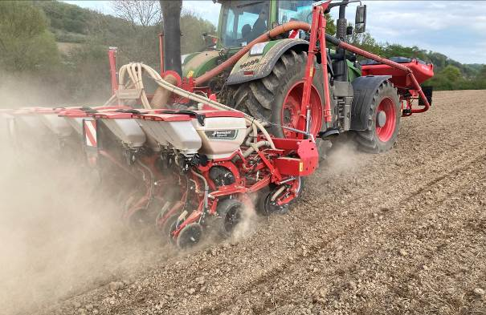

Sustainable agriculture is of utmost importance these days, and innovations that support resource-saving farming are important. With PUDAMA, Kverneland sets new standards in maize seeding; the amount of starter fertiliser needed is reduced by at least 25% thanks to a precise placement of fertiliser spots below and next to the maize seeds.

PUDAMA – High yields in row crops with reduced input
PUDAMA stands for a systematic focused spot fertiliser application during maize sowing. It enables the precise sowing of maize with the synchronised placement of a starter fertiliser deposit exactly next to the maize seed where it is needed.
With this technology, Scientists of the TH Cologne, Institute for Construction and Agricultural Machinery Technology of Cologne have proven that at least 25% of the starter fertiliser can be saved with the PUDAMA system compared to conventional continuous band fertilisation; still the yield potential is maintained.

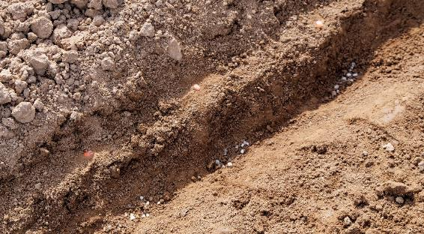
Applying starter fertiliser in deposits as an answer to today’s increasing demand for environmental protection.
The PUDAMA technology has first been incorporated on the trailed frame Optima TFprofi and is now presented on the folding frame Optima F combined with the front hopper f-drill.

Parallel-hydraulic folding frame Optima F
The Optima F is a strong 6.00m hydraulic folding frame with up to 12 SX seeding rows.
Especially adapted to the needs of the professional farmer and contractor, the Optima F offers strong performance in the field. The machine is quickly folded and can be stored in transport position. This is extremely operator-friendly and saves time. The Kverneland Optima F combined with the f-drill front-hopper, which is used for the fertiliser transport is a powerful and maneuverable precision seed drill combination for high performance and optimum weight balance.

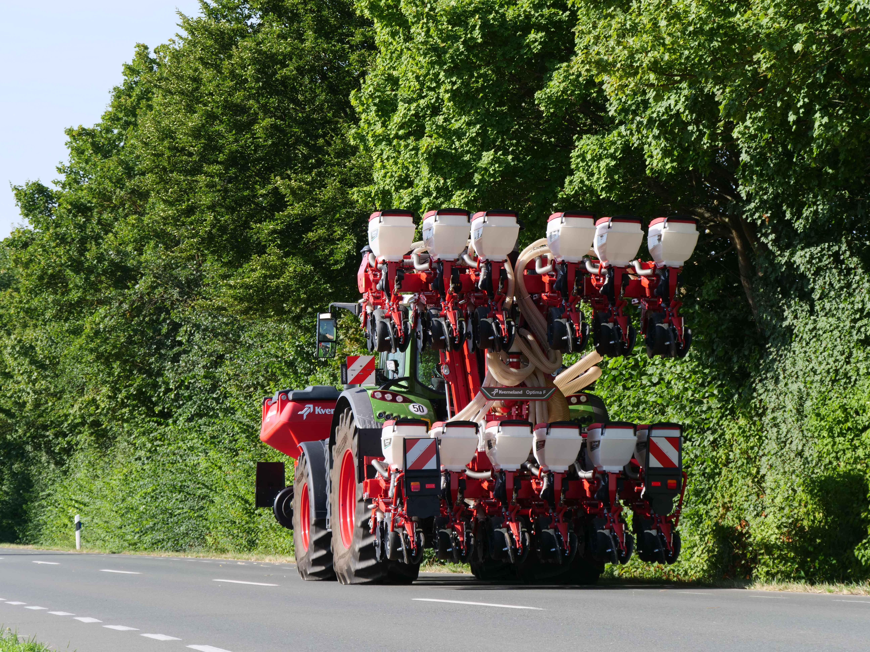

Quickly fold to transport position: Optima F with 12 SX units

PUDAMA on Optima F will first be presented on Agritechnica 2023 and will be available as limited 0-series from season 2024, whilst PUDAMA on Optima TFprofi is already fully available.

Number of characters including spaces: 2449

***

Kverneland is a brand of Kverneland Group
Kverneland Group is a leading international company developing, producing and distributing agricultural machinery and services. Strong focus on innovation allows us to provide a unique and broad product range with high quality. Kverneland Group offers an extensive package aimed at the professional farming community, covering the areas of soil preparation, seeding, forage and bale equipment, spreading, spraying and electronic solutions for agricultural tractors and machinery. For more information on Kverneland Group visit www.kvernelandgroup.com

- - END - -

Download high resolution images
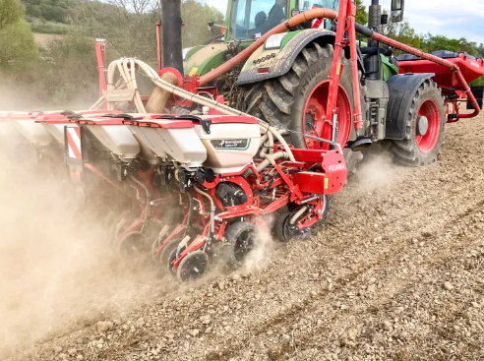
Kverneland-Optima F-PUDAMA field 01


Kverneland PUDAMA Application

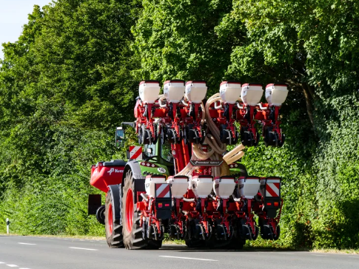
Kverneland-Optima F PUDAMA transport

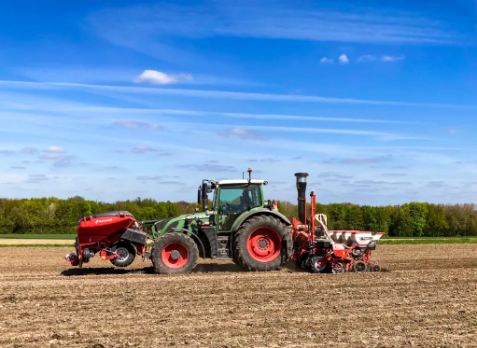
Kverneland-Optima F-PUDAMA-field 02

For Details, Contact:

Nils-Ingvar Kristensson
011-8000 813 / 070-851 21 51
nils-ingvar.kristensson@kvernelandgroup.com

 | Kverneland on Social Media
 |  | Kverneland |  |  | @KvernelandGroup |  |  |  | kvernelandgrp |  |  |  | Kverneland |  |  | Kverneland Group

