PRESS RELEASE

**Kverneland TwinFill**

Automatic filling program for iXter B and iXtra

August 2023 Nieuw-Vennep, The Netherlands

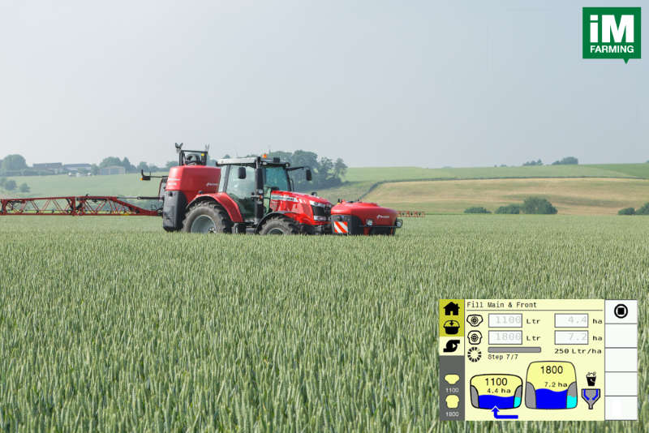

*TwinFill is a combined filling program for the front and rear mounted sprayer*

**Kverneland is going to introduce TwinFill: combined filling for the iXtra front tank in combination with the iXter B rear mounted sprayer at the Kverneland Group Exclusive Media Event 2023 in August in Germany.**

**Filling a Front-rear Sprayer Combination**

Nowadays an operator has two ways of filling his front-rear sprayer combination. Either measuring spray liquid two times for both tanks individually or all at once with a long mixing time needed afterwards. Both are considered to be time consuming and increasing the risk of wrong concentrations. Operators don't want to calculate and add twice the needed spray liquid as this is double work, not user friendly and adding additional failure potential that can lead to extra costs or over/under dosing. When adding the spray liquid at once, so far only solutions of a front-rear combination are known that circulate the mixture between front and rear sprayer tank by transferring back and forth with a pump to aim for equal concentrations in both tanks. The issue here is that it is very difficult or even impossible to know when circulated enough to reach more or less equal concentrations.

**Always the Perfect Concentration**

“TwinFill is an automatic filling program that lets the operator fill his product in one go, for both the front and rear tank, without the disadvantage of unknown mixing time. The software takes care that the spray liquid is split and transferred to the front and rear tank with the correct volume and equal concentration. After, both tanks are filled up with clean water to the required level, the same concentration is reached in both tanks,” says Dirk-Jan Stapel, Director Marketing & Sales Arable Systems Division. He continues: “TwinFill is especially beneficial for medium sized arable farmers, vegetable farmers and contractors in mixed farming areas. The operator can simply fill all of the products in one step to the total required tank volume of the two tanks together or just enter the number of hectares to be sprayed, without having to measure all of the products twice and in different amounts and fill the tanks separately!” With TwinFill the operator can immediately start the spray job, because the mixture in both tanks is perfectly diluted and ready for use - and also from start to finish for the complete spray job. There is also no waste of clean water or spray liquid, because it is exactly calculated upfront how much water or spray liquid is needed.

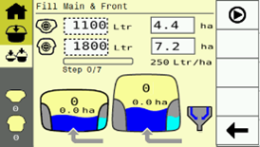

*Enter the requested front and rear volume or number of hectares on the screen of the terminal*

**Multi-Tank-Management**

The iXtra-iXter B combination still keeps its distinctive feature to have a multi-tank usage with two different spray mixes in front and rear tank for different applications or for storage of clean water for later use or to prepare another mixture at another moment at another place.

Number of characters including spaces: 3030

\*\*\*

**Kverneland is a brand of Kverneland Group**

Kverneland Group is a leading international company developing, producing and distributing agricultural implements, electronic solutions and digital services. Productivity, efficiency, and sustainability are three important principles in today's agriculture, driving us every day to continuously develop our Agricultural Implement Technology. Kverneland Group offers an innovative range of soil and seeding equipment, forage and bale equipment, spreading, spraying, electronic solutions and digital farm services for agricultural tractors and implements. For more information on Kverneland Group, visit [www.kvernelandgroup.com](http://www.kvernelandgroup.com)

- - END - -

  
[The principle behind Kverneland TwinFill on the iXter-iXtra sprayer combination](https://youtu.be/YciH7d7RkhU)

Download high resolution images

  
[Kverneland TwinFill automatic filling](https://download.kvernelandgroup.com/Media/Multimedia/kv-twinfill-ixter-ixtra)  
*TwinFill is an automatic filling program for the iXtra front tank in combination with the iXter B rear mounted sprayer*

  
[TwinFill filling screen](https://download.kvernelandgroup.com/Media/Multimedia/kv-twinfill-filling-screen)   
*Enter the desired litres in both tanks or the number of hectares to be sprayed, push start and the front tank will be pre-filled*

**For Details, Contact:**

**Nils-Ingvar Kristensson**

011-8000 813 / 070-851 21 51

nils-ingvar.kristensson@kvernelandgroup.com

|  |  |  |  |  |  |  |  |  |  |  |
| --- | --- | --- | --- | --- | --- | --- | --- | --- | --- | --- |
| **Kverneland on Social Media** | | | | | | | |  | | |
| 2020-07-30_SocialMediaIcons_RGB_Facebook | | [Kverneland](http://www.facebook.com/KvernelandGroup) | 2020-07-30_SocialMediaIcons_RGB_Twitter | [@KvernelandGroup](http://twitter.com/kvernelandgroup) | 2020-07-30_SocialMediaIcons_RGB_YouTube | [kvernelandgrp](http://www.youtube.com/kvernelandgrp) | 2020-07-30_SocialMediaIcons_RGB_Instagram | [Kverneland](https://www.instagram.com/kverneland_ien/) | | 2020-07-30_SocialMediaIcons_RGB_LinkedIn | [Kverneland Group](https://www.linkedin.com/company/kverneland-group/) | |