PRESS RELEASE

**Kverneland f-drill CB F coulter bar   
Efficient in the seeding combination**

01.08.2023, Soest, Germany

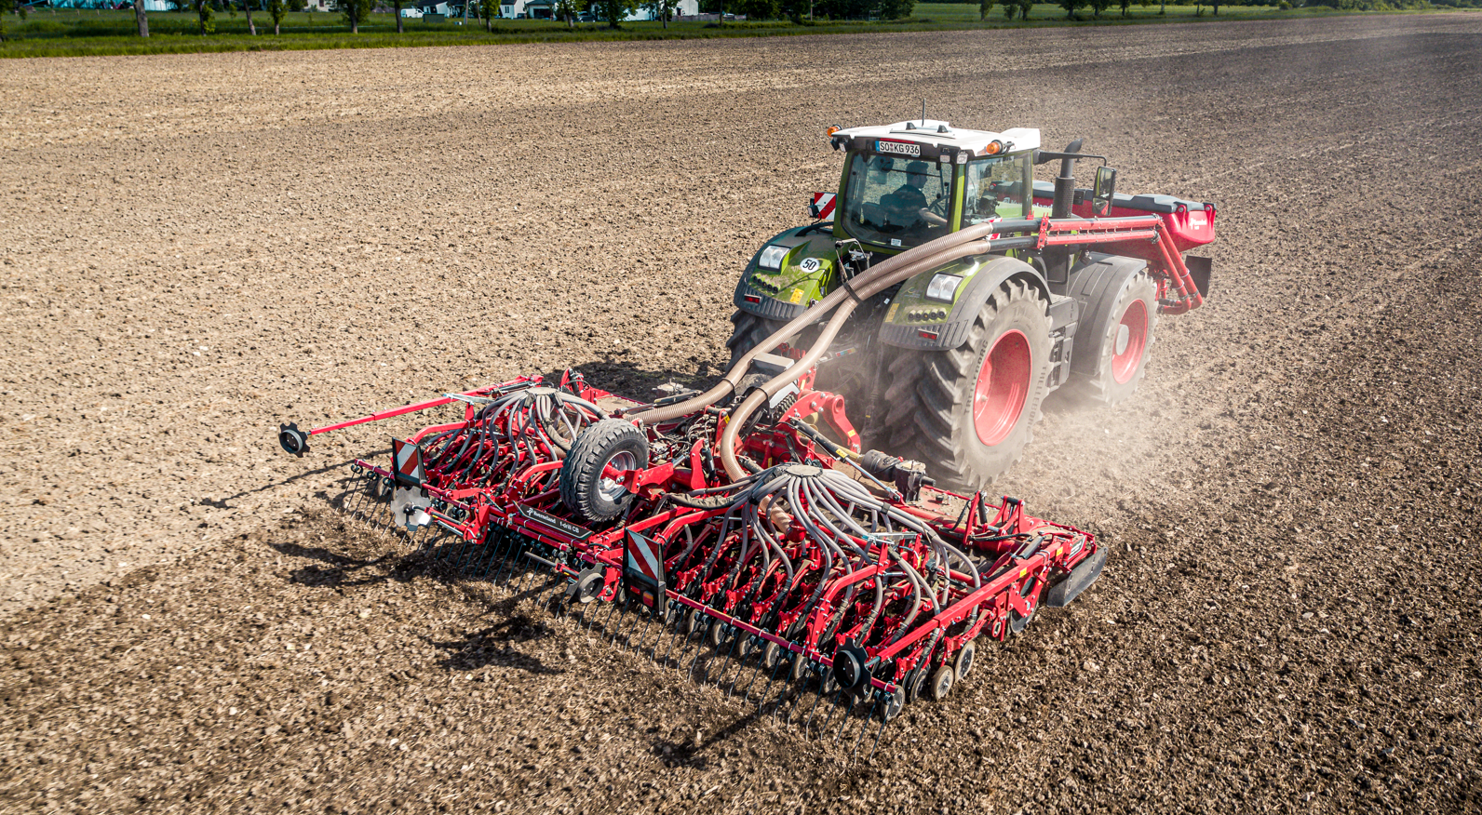

*Kverneland f-drill CB F & Rotago F & f-drill – ready for the future, farming 4.0*

**Kverneland introduced a new folding coulter bar, the f-drill CB F, which builds a perfect seeding combination together with the new power harrow Rotago F and front hopper f-drill models.**

Precision in seed and fertiliser placement are key in efficient and sustainable farming. Reducing the impact on the land and the environment by less wheeling and soil movement whilst ensuring high yields by the most accurate placement of seeds and fertiliser have been the key objectives for the development of the f-drill CB F coulter bar.

**f-drill CB F coulter bar – flexible and precise**

The new Kverneland f-drill CB F is the perfect match for the new Rotago F power harrow. It is available in working width from 4 to 6m. The well-known CX-II or CX-II double entry coulters are bolted to the toolbar to allow various sowing distances. The coulter bar can be ordered with 12.5cm and 25cm in order to meet the individual farming system.

The flexible and individual depth setting of each CX-II coulter allows different sowing depth even within one working width. This is extremely important when sowing two different products in one pass e.g. rape at a shallow depth and companion crops like beans deeper. For wet and sticky soils, a new alternative CX-II coulter is now available as a cost-effective version without press wheel. The special curved design provides sufficient bearing capacity in light conditions.

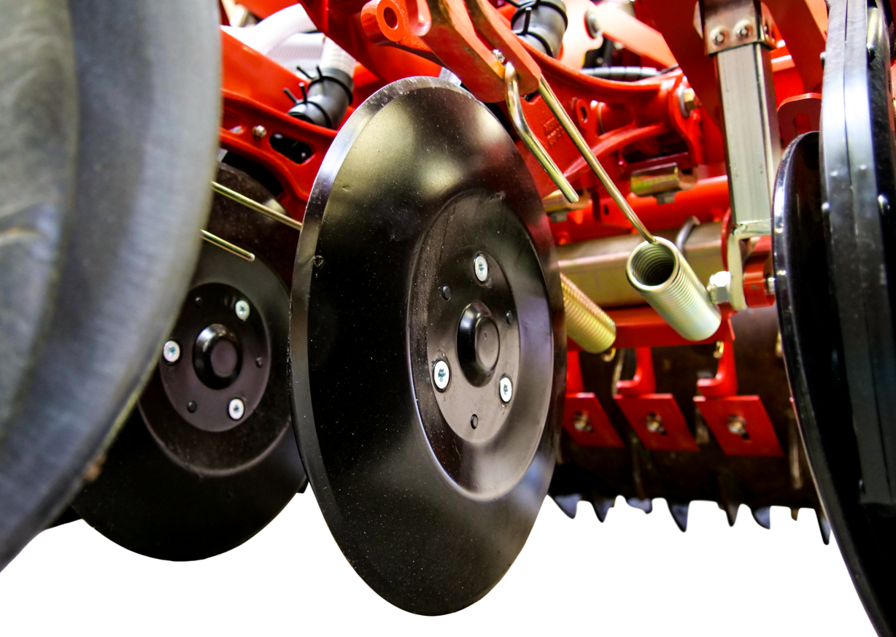

*Kverneland f-drill CB F new bolted CX-II coulter without press wheel*

Depth adjustment and coulter pressure can be easily adapted by hydraulics or as ISOBUS version via the terminal. The CAT. II easy connection allows quick coupling with the ROTAGO F power harrow. The right finish is ensured with the S-tine following harrow.

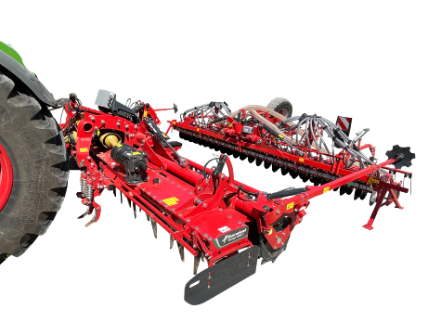

*Kverneland coulter bar f-drill CB F with easy CAT. II connection*

**Easy connection with electronics – intelligent, operator-friendly**

The ISOBUS e-com software’s “plug and play” compatibility enables the f-drill CB F, the power harrow Rotago F and the front hopper f-drill to be connected to any ISOBUS compatible tractor, for fully functional use by the tractor’s own terminal or alternatively, Kverneland’s IsoMatch Tellus Pro or the IsoMatch Tellus GO+.

**Safe on the road**

For better load balance and extra stability, a supporting wheel is available which can be mounted to the coulter bar. No uncoupling of the top linkage is needed. The constant supporting force on the wheel ensures smooth run, legal transport weights and increase driver’s safety and comfort.

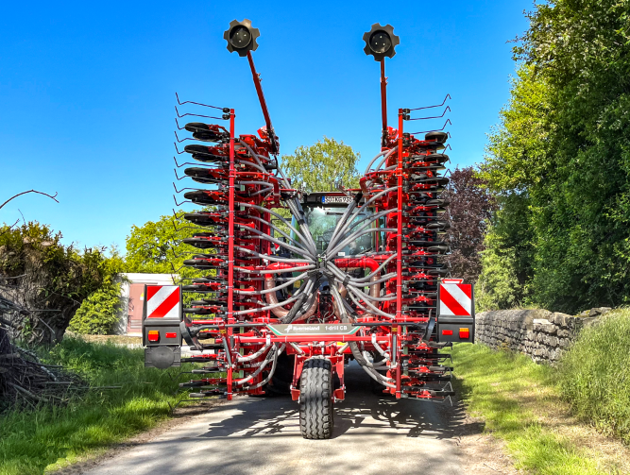

*Kverneland coulter bar f-drill CB F safe road transport with support wheel*

A powerful Kverneland seeding combination stands for sustainability, flexibility, efficiency and intelligence – to be ready for the future.

*Number of characters including spaces: 2874*

\*\*\*

**Kverneland is a brand of Kverneland Group**

Kverneland Group is a leading international company developing, producing and distributing agricultural implements, electronic solutions and digital services. Productivity, efficiency, and sustainability are three important principles in today's agriculture, driving us every day to continuously develop our Agricultural Implement Technology. Kverneland Group offers an innovative range of soil and seeding equipment, forage and bale equipment, spreading, spraying, electronic solutions and digital farm services for agricultural tractors and implements. For more information on Kverneland Group, visit [www.kvernelandgroup.com](http://www.kvernelandgroup.com)

- - END - -

Download high resolution images



[Kverneland-f-drill CB in seeding combination](https://download.kvernelandgroup.com/Media/Images/kverneland-rotago-f-seeding-combination-5.jpg)

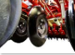

[Kverneland-new-CX-II-coulter.jpg](https://download.kvernelandgroup.com/Media/Images/kverneland-new-cx-ii-coulter-p101234.jpg)

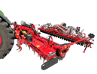

[Kverneland f-drill CB F connection](https://download.kvernelandgroup.com/Media/Images/img_3318-kverneland-rotago-f-coulterbar-attachemnt.png)

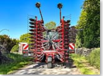

[Kverneland support wheel](https://download.kvernelandgroup.com/Media/Images/kverneland-f-drill-cb-f-transport-img_2619.jpg)

For Details, Contact:

Nils-Ingvar Kristensson  
011-8000 813 / 070-851 21 51  
nils-ingvar.kristensson@kvernelandgroup.com

|  |  |  |  |  |  |  |  |  |  |  |
| --- | --- | --- | --- | --- | --- | --- | --- | --- | --- | --- |
| **Kverneland on Social Media** | | | | | | | |  | | |
| 2020-07-30_SocialMediaIcons_RGB_Facebook | | [Kverneland](http://www.facebook.com/KvernelandGroup) | 2020-07-30_SocialMediaIcons_RGB_Twitter | [@KvernelandGroup](http://twitter.com/kvernelandgroup) | 2020-07-30_SocialMediaIcons_RGB_YouTube | [kvernelandgrp](http://www.youtube.com/kvernelandgrp) | 2020-07-30_SocialMediaIcons_RGB_Instagram | [Kverneland](https://www.instagram.com/kverneland_ien/) | | 2020-07-30_SocialMediaIcons_RGB_LinkedIn | [Kverneland Group](https://www.linkedin.com/company/kverneland-group/) | |