PRESS RELEASE

**Kverneland f-drill maxi plus   
Ready for the future**

01.08.2023, Soest, Germany

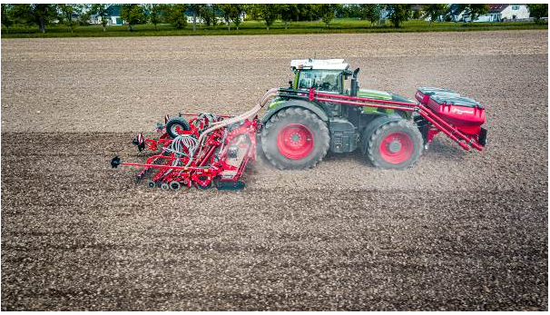

*Kverneland f-drill maxi plus & Rotago F & f-drill CB F – ready for the future, farming 4.0*

**Kverneland has extended the range of front hopper f-drill by the f-drill maxi plus. The f-drill maxi plus offers farmers and contractor additional flexibility as it adapts to all kinds of farming systems and is ready to be combined with different implements for the operation in various working widths.**

The f-drill maxi plus allows seeding and fertilising in one pass but also the combined application of seeds and companion crops. The dissolved set up together with a power harrow and coulter bar shows an optimum weight balance and carries out seedbed preparation and seeding in one pass.

Precision in seed and fertiliser placement are key in efficient and sustainable farming. Reducing the impact on the land and the environment by less wheeling and soil movement whilst ensuring high yields by the most accurate placement of seeds and fertiliser have been the key objectives for the development of the f-drill seeding combination.

**f-drill maxi plus – powerful, flexible, sustainable**

“With the f-drill maxi plus version, we extended our f-drill front hopper range. We are using two independent electric driven metering ELDOS devices and the “maxi” hopper with 2200 litre volume”, Product Manager, Sebastian Koers explains. “The hopper of the maxi plus model is divided to a ratio of 60:40 and allows to meter and applicate two different products with different rates in one pass. If needed, the operator can also use the complete hopper for one product by quickly removing the separating wall, which is simply screwed in place. The hopper offers full flexibility!”

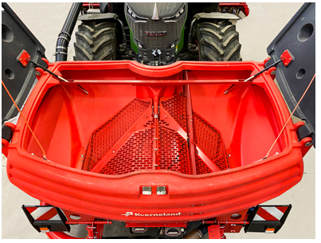

*Kverneland front hopper f-drill maxi plus hopper split 60:40*

The venturi metering system enables also higher application rates. The f-drill maxi plus offers full versatility. It allows the application of

* two types of different seeds or
* seed and fertiliser in one pass and in different application rates.

The flexible and individual depth setting of each CX-II or CX-II double entry coulter at the coulter bar allows different depth adjustment. This is extremely important when sowing two different products in one pass e.g. rape at a shallow depth and companion crops like beans deeper.

Depending on the individual requirements, a front wheel packer or weighing kits can be added to optimise weight balance for the most convenient and safe manoeuvrability and handling. The f-drill maxi plus offers maximum overview due to the compact and low height despite maximum capacity.

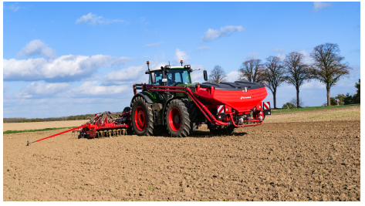

*Kverneland front hopper f-drill maxi plus*

**Easy connection with electronics – intelligent, operator-friendly**

The ISOBUS e-com software’s “plug and play” compatibility enables the f-drill maxi plus and the complete combination to be connected to any ISOBUS compatible tractor, for fully functional use by the tractor’s own terminal or alternatively, Kverneland’s IsoMatch Tellus Pro or the IsoMatch Tellus GO+.

Kverneland f-drill maxi plus stands for sustainability, flexibility, efficiency and intelligence – to be ready for the future.

*Number of characters including spaces: 3113*

\*\*\*

**Kverneland is a brand of Kverneland Group**

Kverneland Group is a leading international company developing, producing and distributing agricultural implements, electronic solutions and digital services. Productivity, efficiency, and sustainability are three important principles in today's agriculture, driving us every day to continuously develop our Agricultural Implement Technology. Kverneland Group offers an innovative range of soil and seeding equipment, forage and bale equipment, spreading, spraying, electronic solutions and digital farm services for agricultural tractors and implements. For more information on Kverneland Group, visit [www.kvernelandgroup.com](http://www.kvernelandgroup.com)

- - END - -

Download high resolution images

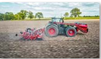

[Kverneland f-drill maxi plus in combination](https://download.kvernelandgroup.com/Media/Images/kverneland-rotago-f-drill-f-drill-cb-field-22.jpg)

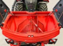

[Kverneland-f-drill-maxi-plus](https://download.kvernelandgroup.com/Media/Images/kverneland-f-drill-maxi-plus-deetail-img_8578.jpg)

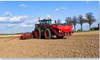

[Kverneland f-drill maxi plus](https://download.kvernelandgroup.com/Media/Images/kverneland-f-drill-maxi-plus-field-p10116781.jpg)

For Details, Contact:

Nils-Ingvar Kristensson

011-8000 813 / 070-851 21 51

nils-ingvar.kristensson@kvernelandgroup.com

|  |  |  |  |  |  |  |  |  |  |  |
| --- | --- | --- | --- | --- | --- | --- | --- | --- | --- | --- |
| **Kverneland on Social Media** | | | | | | | |  | | |
| 2020-07-30_SocialMediaIcons_RGB_Facebook | | [Kverneland](http://www.facebook.com/KvernelandGroup) | 2020-07-30_SocialMediaIcons_RGB_Twitter | [@KvernelandGroup](http://twitter.com/kvernelandgroup) | 2020-07-30_SocialMediaIcons_RGB_YouTube | [kvernelandgrp](http://www.youtube.com/kvernelandgrp) | 2020-07-30_SocialMediaIcons_RGB_Instagram | [Kverneland](https://www.instagram.com/kverneland_ien/) | | 2020-07-30_SocialMediaIcons_RGB_LinkedIn | [Kverneland Group](https://www.linkedin.com/company/kverneland-group/) | |